Brandon Langley

CPSC 4820

Linear Regression and Gradient Descent

Project 2: Report

September 30, 2019

**Problem Description**

An Entrepreneur has an idea for an app which will assist student decision making regarding drinking beer and studying. They have collected data from 300 students which consists of the time spent studying per week (in minutes), the volume of beer they consume per week (in ounces), as well as each students grade point average for the semester. Given the data set develop a linear regression model of the form y=w0+w1x1+w2x2 and train the algorithm using gradient descent. The goal is to have the model be implemented in an app so that students can enter the amount of beer they consume and the time they spend studying and the app will predict the student’s GPA.

**Data Description**

The data is given in a txt file, the fist line of which represents the count of the number of records in the file, the remainder of the file contains the data collected from each student. Each line of the file contains the record for one individual student consisting of 3-tab separated values corresponding to the time spent studying, oz of beer, and GPA, in that order.

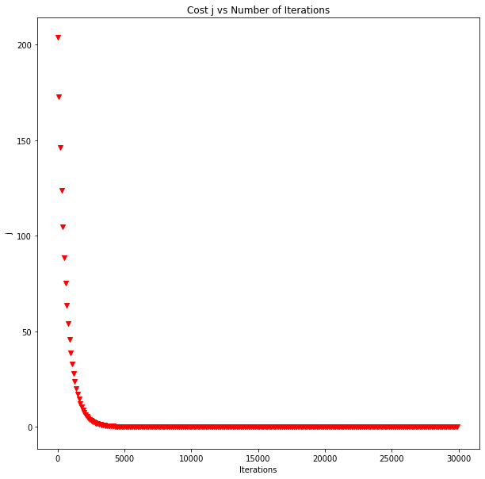

**Developing the Algorithm**

Initially the data was read in and immediately randomized, it was then divided into a Training Set (70% or 210 record) and a Test Set (30% or 90 records). Then the linear regression model was trained using the training set. The initial values passed to the model were as follows; weights: W0=0, W1=0, W2=0 and learning rate alpha=0.1. However, immediately after attempting to run the algorithm with these values it became apparent that this value for alpha was much too large, after testing a variety of alpha values alpha=0.00001 was found to be more appropriate. With this value for alpha the initial value for J was 214.514 which is very high indicating the weights are still very far off. Next the algorithm was allowed to iterate and train the weights until J(w0,w1,w2) converged. After allowing the algorithm to iterate 50,000 times it was found that J converged around .17 after approximately 20,000 iterations. This can be seen in Figure.1. For this reason, J was taken to converge after 20,000 iterations. Additionally, to illustrate 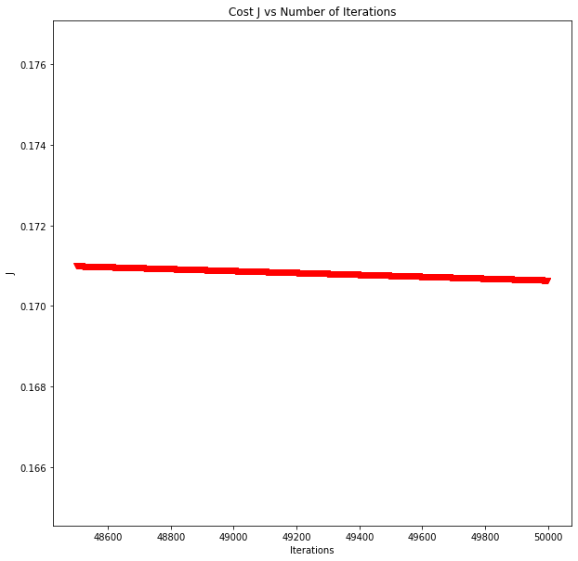the convergence of J Figure 2 shows the small change in j over the final 2,500 iterations.

Figure 1: Graph Comparing J vs Number of iterations

**Results**

After the final training run, the algorithm gave the following weights: W0=-0.17287292, W1=0.00354258, W2=0.00151283. The final value of J on the training set was J= 0.17064016. Using these weight values to calculate the cost J on the Test Set gave a result of J=0. 07458331.

Figure 2: Graph of J values for the final 5,000 iterations